EXPERIMENT-22
22) Implement the Closing technique as a Morphological operation to dilate the foreground regions based on Open CV.
a)CODE
import cv2
import numpy as np
import os

path = r"C:\Users\Varshini varshini\Desktop\photo.jpg"
img = cv2.imread(path, 0)

if img is None:
print("Image not found! Check photo.jpg path")
else:
kernel = np.ones((5, 5), np.uint8)
closing = cv2.morphologyEx(img, cv2.MORPH_CLOSE, kernel)

out = r"C:\Users\Varshini varshini\Desktop\closing_output.jpg"
cv2.imwrite(out, closing)
print("Output saved on Desktop")
cv2.imshow("Closing Output", closing)
cv2.waitKey(0)
cv2.destroyAllWindows()

b) INPUT
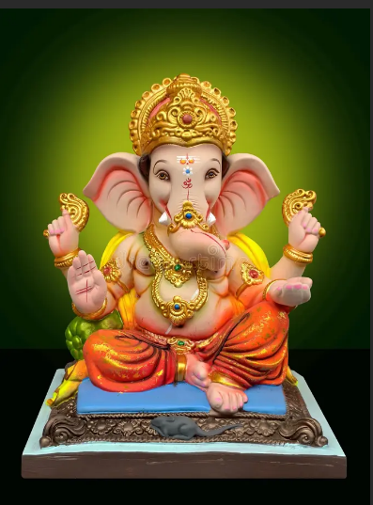

C) OUTPUT
